**CAFETERIA**

**MANAGEMENT**

**SYSTEM**

**Tables:-**

show tables;

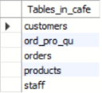

**Staff Table:-**

desc staff;

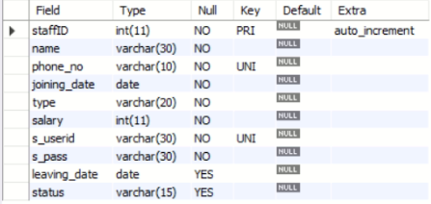

select * from staff;

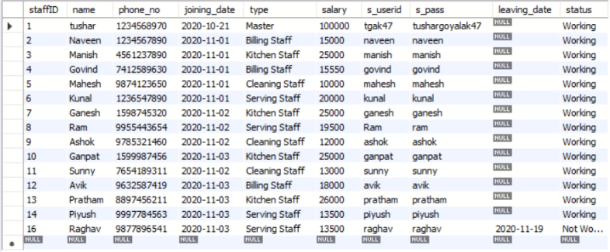

**Customer Table:-**

desc customers;

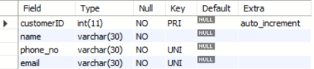

select * from customers;

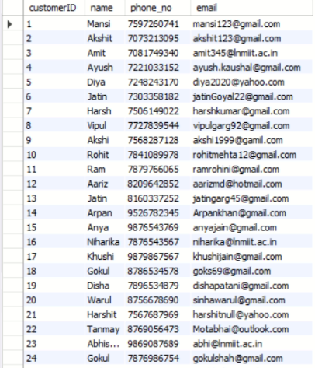



**Product Table:-**

desc products;

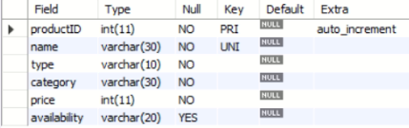

select * from products;

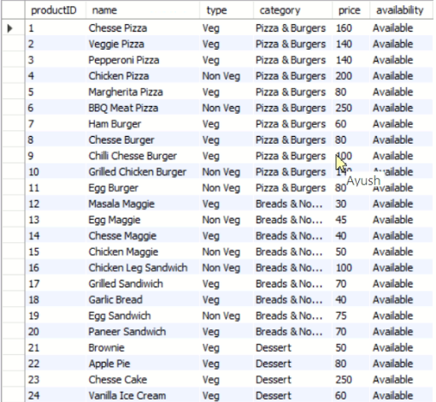

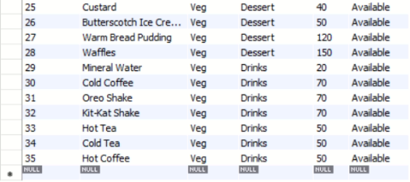

**Order Table:-**

desc orders;

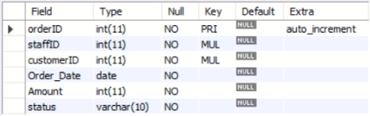

select * from orders;

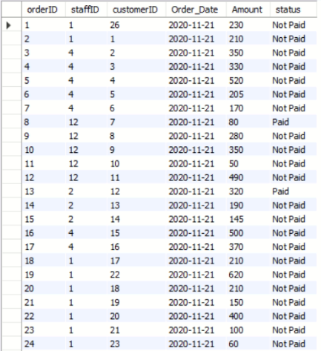



**Order_Product_Quantity Table:-**

desc ord_pro_qu;

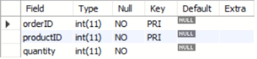

select * from ord_pro_qu;

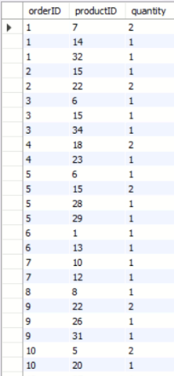 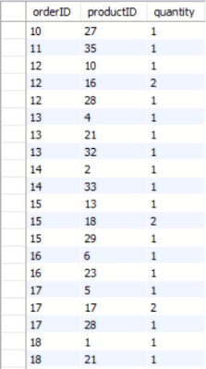 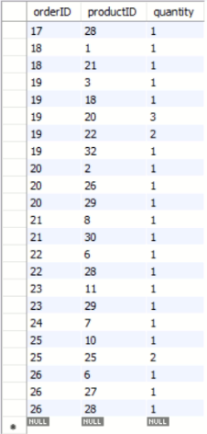

**This table consists of orderID, productID and quantity as its fields where orderID and productID are the composite keys which are also the foreign keys of orders table and products table respectively. This table is necessary as orders table and products table have an m:n relationship.

**E-R MODEL**

